# Probabilities from the Normal Distribution

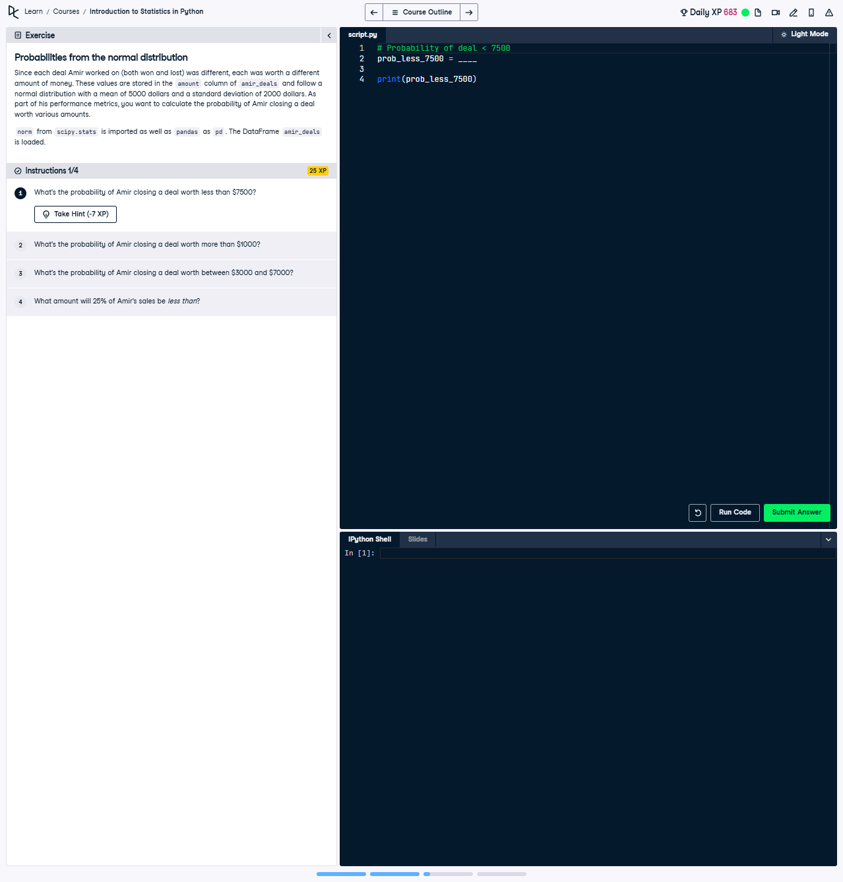

## Question:

What's the probability of Amir closing a deal worth less than 7500?  
Given: Amir's deals follow a normal distribution with a mean of 5000 dollars and a standard deviation of 2000 dollars.

## Explanation of the Question:

This question requires calculating the cumulative probability of closing a deal worth less than 7500 dollars using a normal distribution with a given mean (5000) and standard deviation (2000). The cumulative distribution function (CDF) of the normal distribution is used for this.

## Answer:

from scipy.stats import norm  
  
# Use the CDF to find the probability of a deal being less than $7500  
prob_less_7500 = norm.cdf(7500, 5000, 2000)  
  
print(prob_less_7500)

## Explanation of the Answer:

The `norm.cdf` function from scipy.stats computes the cumulative probability up to a given value in a normal distribution. Here, 7500 is the value, with a mean of 5000 and standard deviation of 2000. The result gives the probability of closing a deal worth less than 7500 dollars.